Steps to install lamp on centos 7

Installing apache on centos 7

Step 1:Update Software Versions List

sudo yum update

Step 2: Install Apache

sudo yum install httpd -y

Step 3: Activate Apache

sudo systemctl start httpd

Step 4:set the Apache service to start when the system boots

sudo systemctl enable httpd

Step 5: Verify Apache Service

sudo systemctl status httpd

OUTPUT

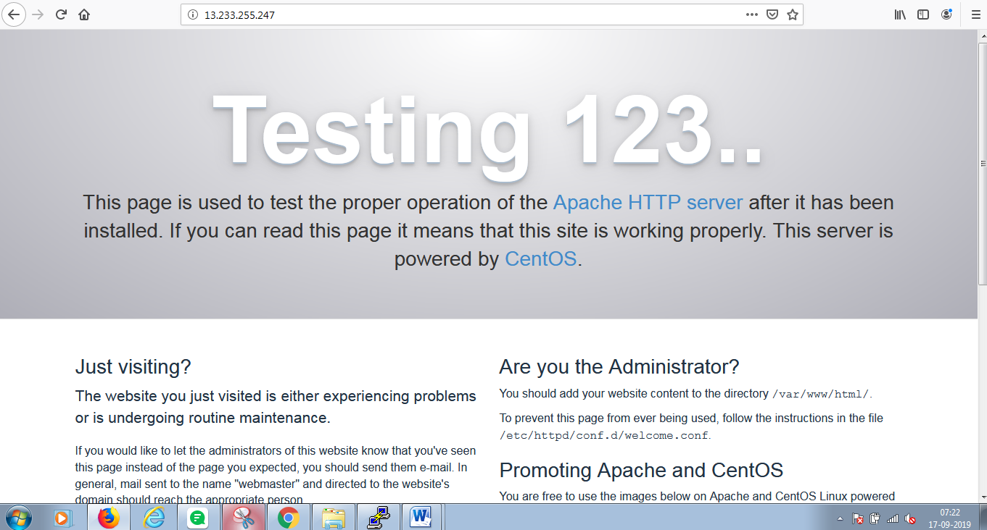

Link https://hostadvice.com/how-to/how-to-install-lamp-stack-on-centos-7/

Installing mysql on centos 7

Step 6:before you install mysql use below command to update and install wget.

sudo yum update

yum install wget

Step 7:MySQL must be installed from the community repository.

wget http://repo.mysql.com/mysql-community-release-el7-5.noarch.rpm

sudo rpm -ivh mysql-community-release-el7-5.noarch.rpm

yum update

step 8:Install MySQL as usual and start the service.

sudo yum install mysql-server

sudo systemctl start mysqld

step 9:Run the mysql_secure_installation script to address several security concerns in a default MySQLnstallation.

sudo mysql_secure_installation

step 10:To log in to MySQL as the root user:

mysql -u root –p

---------------------------------

Enter the password and type Exit to come out from mysql.

Installation Steps of PHP 7.0, 7.1 & 7.2 on CentOS 7

Step 1:Install yum-utils and enable EPEL repository

yum install epel-release yum-utils –y

step 2:Download and Install remirepo using yum command

yum install http://rpms.remirepo.net/enterprise/remi-release-7.rpm

yum-config-manager --enable remi-php72

step 3: Install PHP 7.2 along with dependencies.

yum install php php-common php-opcache php-mcrypt php-cli php-gd php-curl php-mysql -y

step 4: Verify the PHP version

php -v

Step5: start its service using below systemctl command

systemctl start httpd

Now create a **info.php** file under /var/www/html with following contents,

cd /var/www/html/

vi info.php

================

<?php

phpinfo();

?>

Save and exit and restart apache server

systemctl restart httpd

Open the web browser and type the ip of your server followed by info.php,

<http://Server-IP-Address/info.php>

OUTPUT

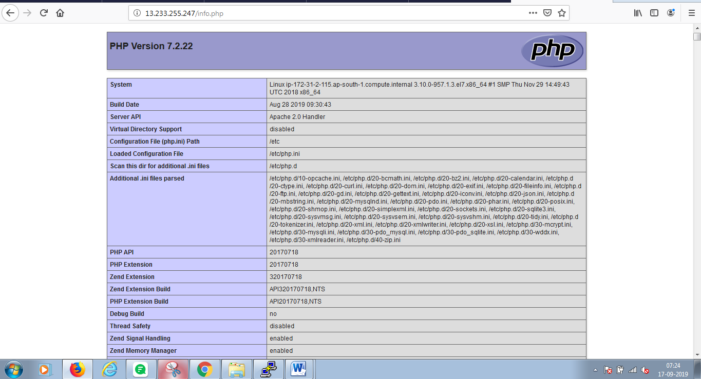

https://www.linuxtechi.com/install-php-7-centos-7-rhel-7-server/

Installing phpMyAdmin on centos 7

step 1:phpMyAdmin is not available in CentOS 7 core repositories. To install phpMyAdmin we need to enable the EPEL repository first:

sudo yum install epel-release

step 2: Once the EPEL repository is enabled we can install phpMyAdmin and all of it’s dependencies with the following command:

sudo yum install phpmyadmin -y

Now we configure phpMyAdmin

nano /etc/httpd/conf.d/phpMyAdmin.conf

<Directory /usr/share/phpMyAdmin/>  
 AddDefaultCharset UTF-8  
  
 <IfModule mod_authz_core.c>  
 # Apache 2.4  
# <RequireAny>  
# Require ip 127.0.0.1  
# Require ip ::1  
# </RequireAny>  
 Require all granted  
 </IfModule>

Save and exit using ESC :wq! enter.

step 3:Restart the Apache service:

systemctl restart httpd

step4:Now you can access the phpmyadmin console by navigating to the URL

http://server-ip-address/phpmyadmin/ from your browser.

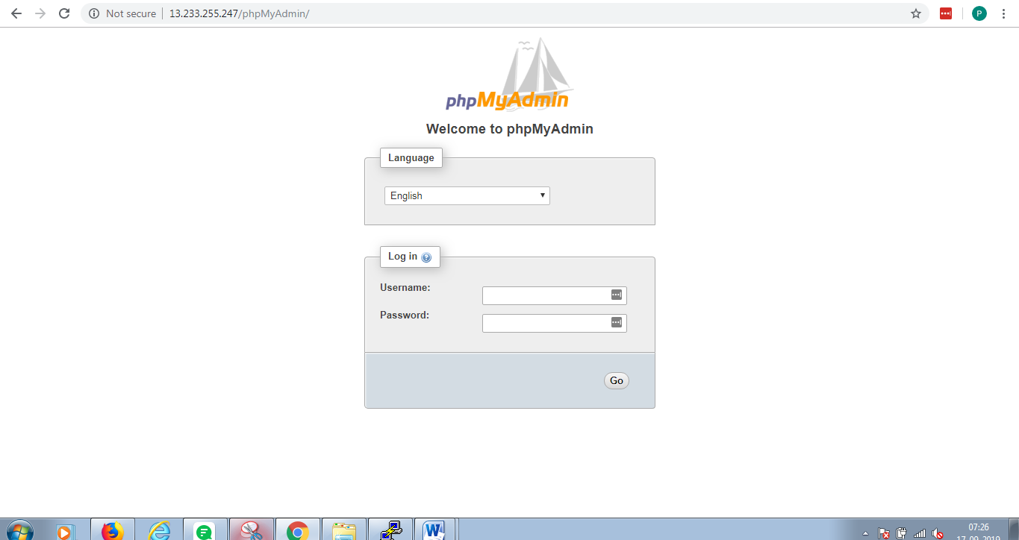

Enter your MySQL username and password which you have given in previous steps. In my case its “root” and passwd

“Parasu@123”.

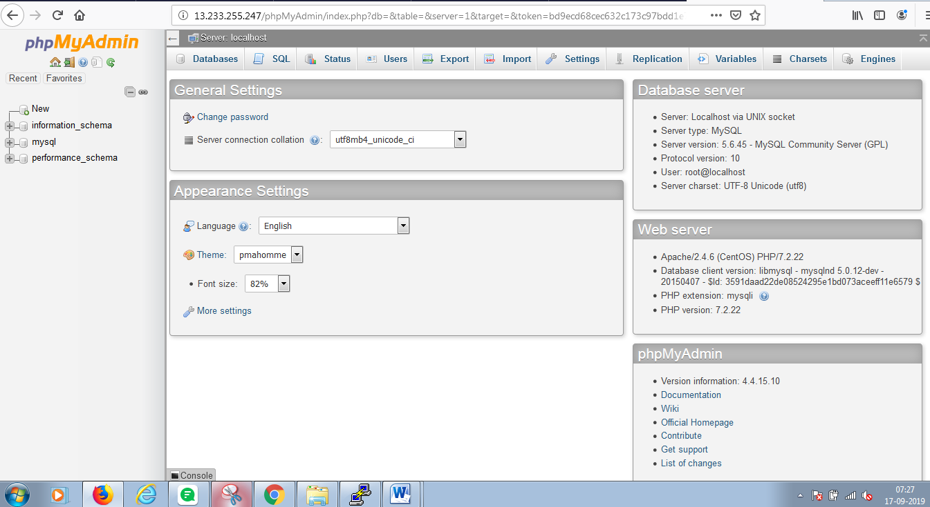

<https://www.howtoforge.com/tutorial/centos-lamp-server-apache-mysql-php/>

Configure Multiple-Wordpress sites on a single server

**How to setup WordPress.**

# wget <http://wordpress.org/latest.tar.gz>

Unzip the compressed file into the desired location.

# tar -xvzf latest.tar.gz

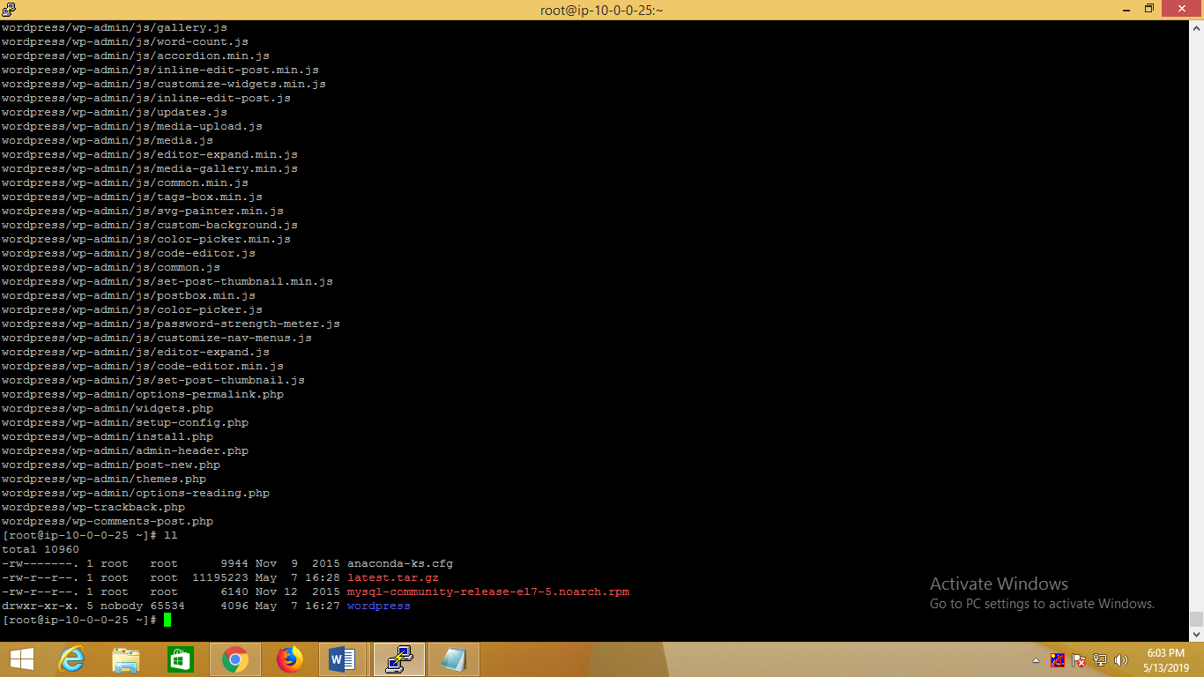

**When you unzip the file successfully one directory will appear name called ‘Wordpress’ as shown above picture**.

Creating MySQL User and database for WordPress-

Login to MySQL Shell:

# mysql –u root –p

# create database database1;

# create user user1;

# Set password for user1=password("admin123");

Now, provide all **privileges** to this new user.

#grant all privileges on database1.* to user1 identified by 'admin123';

At last, refresh MySQL:-

# Flush privileges;

#exit

**Now go to wordpress directory by using cd command**

#ls –for list

# cd wordpress

#ll

List showed all which are present in wordpress

Copy **wp-config-sample.php** to **wp-config.php**

# Cp **wp-config-sample.php**  **wp-config.php**

Open**wp-config.php,**update the **database, user, and**its**password using vi editor**

**#** vi wp-config.php

Change the database name, database username and password.

Now Save and exit from vi editor.

**Copy this WordPress directory into Server**

# cp -r ~/wordpress/* /var/www/html

Next restart Apache services.

# service httpd restart

If you want you can restart the mysql service also.

# service mysqld restart

#cd /var/www/html

#ll

**You have to create database in mysql prompt, exactly same before what we done, just change the names.**

Login to MySQL Shell:

# mysql –u root –p

# create database database2;

# create user user2;

# Set password for user2=password("admin123");

Now, provide all **privileges** to this new user.

#grant all privileges on database2.* to user2 identified by 'admin123';

At last, refresh MySQL:-

# Flush privileges;

#exit

Go to directory cd /var/www/html/

# cd /var/www/html/

Make a directory in html with name wordpress

#mkdir wordpress

List out the files

#ls

#ll

Go to wordpress from root directory

#cd wordpress/

Copy the wordpress data from root directory to cd /var/www/html/wordpress using below command

cp -r ~/wordpress/* /var/www/html/wordpress/

List out all the files.

#ls

Copy **wp-config-sample.php** to **wp-config.php**

# cp wp-config-sample.php wp-config.php

Open**wp-config.php,**update the **database, user, and**its**password using vi editor**

**#** vi wp-config.php

Change the database name, database username and password.

Now Save and exit from vi editor.

**Copy this WordPress directory into Server**

**Multiple site configuration**

Now we will proceed with the multiple site configuration, for this we need to add these lines to our *wp-config.php*

**#** vi wp-config.php

*Add the below line at the end of config file.*

**[...]-----------------------------------------------**

**/* Multisite */**

**define('WP_ALLOW_MULTISITE', true);**

**/* That's all, stop editing! Happy blogging. */**

**[...]---------------------------------------------**

**Save and exit**

Restart the apache server

#service httpd restart

**Apache Rewrite:**

We will modify the apache virtual host file for WordPress to get it allowed for *.htaccess* overrides

Create file

#touch /var/www/html/wordpress/.htaccess

#touch /var/www/html/.htaccess

Change the ownership of .htaccess

#chown apache:apache /var/www/html/wordpress/.htaccess

#chown apache:apache /var/www/html/.htaccess

#chmod 664 /var/www/html/wordpress/.htaccess

#chmod 664 /var/www/html/.htaccess

Restart the apache server

#systemctl restart httpd

#systemctl restart mysqld

Output

Wordpress1:

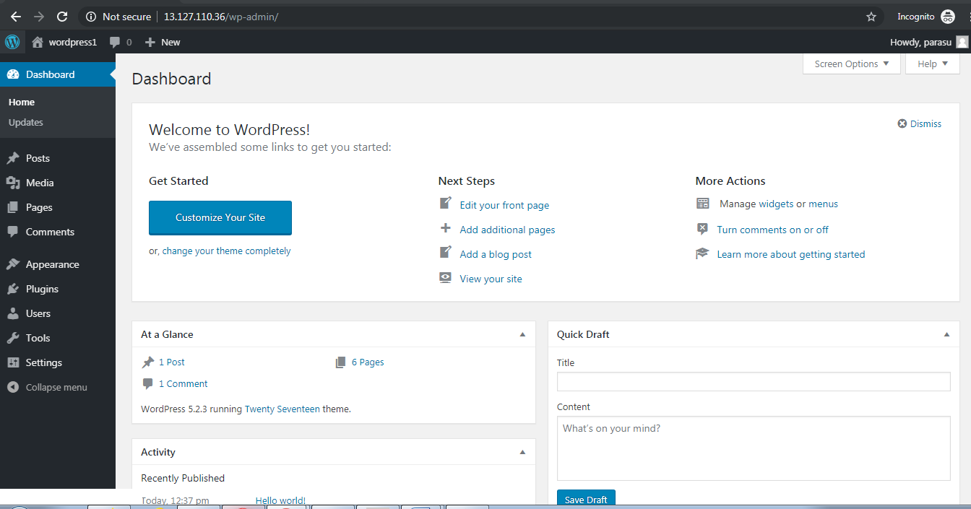

Output:2

Wordpress2

